**SOUND OPERATED SWITCH WITH A RELAY DRIVER**

This sensitive sound operated switch can be used with a dynamic microphone insert as above, or be used with an electret (ECM) microphone. If an ECM is used then R1 (shown dotted) will need to be included. A suitable value would be between 2.2k and 10kohms.

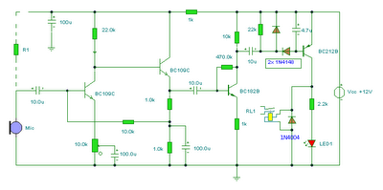

The two BC109C transistors form an audio preamp, the gain of which is controlled by the 10k preset. The output is further amplified by a BC182B transistor. To prevent instability the preamp is decoupled with a 100u capacitor and 1k resistor. The audio voltage at the collector of the BC182B is rectified by the two 1N4148 diodes and 4.7u capacitor. This dc voltage will directly drive the BC212B transistor and operate the relay and LED. It should be noted that this circuit does not “latch”. The relay and LED operate momentarily in response to audio peaks.

The gain of the circuit and sensitivity is controlled by the 10k variable resistor on the emitter of the first (left hand side) transistor. A preset may be used if gain is fixed, a potentiometer should be used to trigger at different sound levels.The relay contacts close and then open (momentary action) in response to audio peaks, these can be used to switch other circuit. The diode across the relay is the usual back emf diode and a 1N4003 or 1N4004 will work well here, preventing damage to the transistor.